[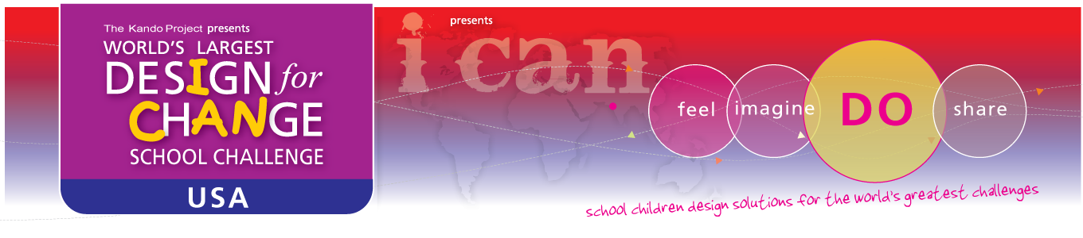](http://www.designforchange.us)

Working Backwards Timeline Planner

To sketch out your plan, start from the bottom of the last page and put your intended date for submission. This timeline provides slots for 26 class periods. You can adjust for more or fewer depending on your circumstance. There is space provided for planning or reflection notes.

|  |  |
| --- | --- |
| Date | Introduction  Icebreakers, Videos, Essential Questions |
| _______ | ______________________________________________  ______________________________________________  ______________________________________________ |
| _______ | ______________________________________________  ______________________________________________  ______________________________________________ |
| _______ | ______________________________________________  ______________________________________________  ______________________________________________ |
| Date | Feel  Student Survey, Decision Tree, Curriculum Toolkit Activities |
| _______ | ______________________________________________  ______________________________________________  ______________________________________________ |
| _______ | ______________________________________________  ______________________________________________  ______________________________________________ |
| _______ | ______________________________________________  ______________________________________________  ______________________________________________ |
| Date | Imagine  Curriculum Toolkit Activities, students determine and plan the Project |
| _______ | ______________________________________________  ______________________________________________  ______________________________________________ |
| _______ | ______________________________________________  ______________________________________________  ______________________________________________ |
| _______ | ______________________________________________  ______________________________________________  ______________________________________________ |
| _______ | ______________________________________________  ______________________________________________  ______________________________________________ |
| _______ | ______________________________________________  ______________________________________________  ______________________________________________ |
| Date | Do  Curriculum Toolkit Activities, Student-driven work |
| _______ | ______________________________________________  ______________________________________________  ______________________________________________ |
| _______ | ______________________________________________  ______________________________________________  ______________________________________________ |
| _______ | ______________________________________________  ______________________________________________  ______________________________________________ |
| _______ | ______________________________________________  ______________________________________________  ______________________________________________ |
| _______ | ______________________________________________  ______________________________________________  ______________________________________________ |
| _______ | ______________________________________________  ______________________________________________  ______________________________________________ |
| _______ | ______________________________________________  ______________________________________________  ______________________________________________ |
| _______ | ______________________________________________  ______________________________________________  ______________________________________________ |
| _______ | ______________________________________________  ______________________________________________  ______________________________________________ |
| _______ | ______________________________________________  ______________________________________________  ______________________________________________ |
| _______ | ______________________________________________  ______________________________________________  ______________________________________________ |
| Date | Share  Complete the Documentation, Share with parents and school, Celebrate, Submit to Design for Change |
| _______ | ______________________________________________  ______________________________________________  ______________________________________________ |
| _______ | ______________________________________________  ______________________________________________  ______________________________________________ |
| _______ | ______________________________________________  ______________________________________________  ______________________________________________ |